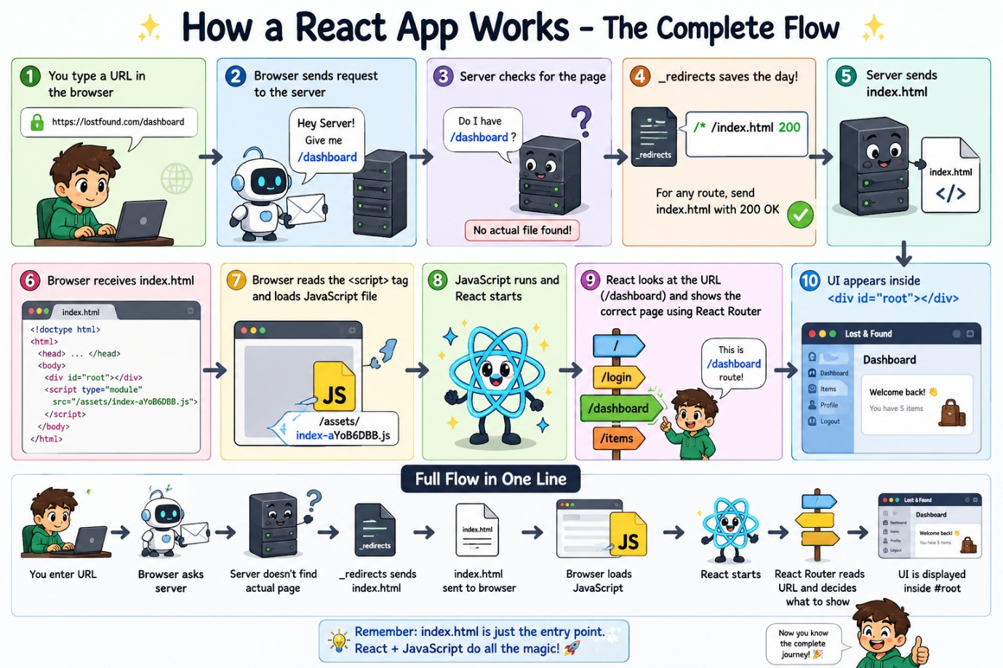
Compressed/Optimized version of project we got after “npm run build”
And Refresh the page

📚 How a React Application Works — Complete Beginner Notes

🗺️ Learning Roadmap
PART 1 → What happens when you create and run a React project?
PART 2 → index.html and the root div
PART 3 → How React components are connected
PART 4 → What npm run build does
PART 5 → What happens when you open/refresh a URL?
PART 6 → React Router and the _redirects problem
PART 7 → Complete flow from URL to UI

🌱 PART 1: What Happens When You Create and Run a React Project?

❓ Q1: What files do we write when creating a React project?
When building a React application, we write our code in multiple files:
frontend/
│
├── index.html
│
└── src/
├── main.jsx
├── App.jsx
├── Login.jsx
├── Dashboard.jsx
└── other components...
Each file has a different responsibility.
For example:
- Login.jsx → Login page UI
- Dashboard.jsx → Dashboard UI
- App.jsx → Connects major parts of the application
- main.jsx → Starts the React application

❓ Q2: Does the browser directly understand .jsx files?
Not exactly.
The browser ultimately works with:
HTML
CSS
JavaScript
React and Vite help convert and organize our React code so the browser can run it.
That's why we use tools like Vite.

❓ Q3: What happens when we run npm run dev?
When you run:
npm run dev
Vite starts a development server.
Then you open the URL shown in the terminal, usually something similar to:
http://localhost:5173
The browser requests your React application.
The basic flow is:
Browser
↓
Vite Development Server
↓
index.html
↓
main.jsx
↓
React Application Starts
↓
UI appears 🎉

🚪 PART 2: Why is index.html Important?

❓ Q4: What is index.html?
index.html is the starting HTML page of your React application.
A simplified version looks like:
<head>
<script type="module" src="/src/main.jsx"></script>
</head>
<body>
<div id="root"></div>

</body>

❓ Q5: How does index.html bring JavaScript into the browser?
This line does it:
<script type="module" src="/src/main.jsx"></script>
The browser reads this and understands:
"I need to load and run this JavaScript file."
So the flow is:
Browser receives index.html
↓
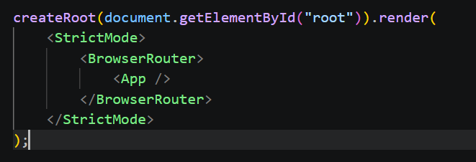
Browser reads the <script> tag
↓
Browser loads main.jsx
↓
JavaScript starts running
↓
React starts 🚀
📌 The <script> tag is what connects index.html to your JavaScript application.

📦 PART 3: What is <div id="root"></div>?

❓ Q6: Why do we have an empty root div?
Initially, this is just an empty container:
<div id="root"></div>
it can display your application's UI.
That location is called the root.

❓ Q7: How does React put content inside an empty root div?
Inside main.jsx, you usually have code similar to:
ReactDOM.createRoot(document.getElementById('root') ).render(
<App />
)
main.jsx finds the element with id="root" in index.html and tells React to render (display) the <App /> component inside it.
Let's understand it step by step.

Step 1: Find the root
document.getElementById('root')
JavaScript searches for:
<div id="root"></div>

Step 2: Give that location to React
ReactDOM.createRoot(...)
This tells React:
"This is the main place where you should manage and display the UI."

Step 3: Display the App
.render(<App />)
This tells React:
"Start rendering my App component."
The flow becomes:
main.jsx
↓
Finds #root
↓
React starts
↓
<App /> is rendered
↓
App and other components create UI
↓
UI appears inside #root 🎉

❓ Q8: But index.html is empty. How does the UI actually appear?
Excellent point! The UI is not manually written inside index.html.
React creates and updates the UI dynamically.
For example, initially:
<div id="root"></div>
After React starts, the browser displays your React UI inside that area:
#root
│
├── Navbar
├── Login Page
├── Dashboard
└── Other Components
So remember:
index.html provides the empty place. React fills that place with your UI.

🔗 PART 4: How Are All the Other JavaScript Files Connected?
You might wonder:
"Okay, index.html loads main.jsx. But how does it know about App.jsx, Login.jsx, and all my other files?"
The answer is imports.
For example:
index.html
↓
main.jsx
↓ imports
App.jsx
↓ imports
Login.jsx, Dashboard.jsx, etc.

📌 Vite follows these connections while developing and later processes them during the production build.

🧠 PART 1–4: The Simple Overall Flow
When you run your application during development:
🌐 Browser opens the website
↓
📄 index.html is loaded
↓
⚡ <script> tells browser to load main.jsx
↓
⚛️ main.jsx starts React
↓
📦 React finds <div id="root">
↓
🏠 App.jsx and other components are rendered
↓
🎉 Your UI appears on the screen

🏗️ PART 2: What Happens When You Run npm run build?
In Part 1, we understood how React works while developing.
Now let's understand what happens when your project is ready to be deployed. 🚀

❓ Q1: Why do we need npm run build?
While developing, your project contains many separate files:
src/
├── main.jsx
├── App.jsx
├── Login.jsx
├── Dashboard.jsx
├── components/
│ ├── Navbar.jsx
│ └── Items.jsx
└── ...
These files are easy for developers to understand and edit.
But when we deploy the application, we want a version optimized for the browser and production.
So we run:
npm run build
This tells Vite:
"Prepare my React project for production."

❓ Q2: What does Vite do during the build?
Vite starts from the entry point and follows the connections between your files.
Remember the connection we learned in Part 1:
index.html
↓
main.jsx
↓
App.jsx
↓
Other Components
Vite follows the import statements and finds the files needed by your application.
Then it:
- Processes the React/JSX code
- Optimizes the JavaScript
- Optimizes CSS
- Creates production-ready files
The result is placed inside the:
dist/
folder.

❓ Q3: What is the dist folder?
dist means distribution.
It contains the final version of your frontend that is ready to be deployed.
After building, you may see something like:
dist/
├── index.html
├── _redirects
└── assets/
├── index-aYoB6DBB.js optimised/combined version of frontend
├── index-CCW-5Wfe.css
└── other files...
📌 When deploying a Vite frontend, the hosting platform usually serves the files from this built output folder.

❓ Q4: What happens to all my .jsx files?
Your original files are still present in your project:
src/
├── App.jsx
├── Login.jsx
└── Dashboard.jsx
But Vite processes and packages the code needed for the browser into production JavaScript files.
Conceptually:
App.jsx ─────────┐
Login.jsx ───────┤
Dashboard.jsx ───┤
Other files ─────┤
↓
Vite Build
↓
Optimized JavaScript
↓
assets/index-xxxx.js
So the browser doesn't need to separately understand your original project structure.

❓ Q5: Is the entire project combined into one JavaScript file?
Not necessarily. 👍
Vite takes all the code needed by your application and creates optimized browser-ready JavaScript files.
Sometimes code may be placed in multiple files (called chunks) for better performance.

❓ Q6: Where does index-aYoB6DBB.js come from?
It is automatically generated during:
npm run build
For example:
Your source code
↓
npm run build
↓
Vite creates
↓
dist/assets/index-aYoB6DBB.js
You do not manually create this file.

❓ Q7: Why does the filename have strange characters?
For example:
index-aYoB6DBB.js
The part:
aYoB6DBB
is a generated hash.
When your code changes and you build again, Vite can generate a different filename.
For example:
index-aYoB6DBB.js ← Old build
index-Xy72KpL9.js ← New build
This helps browsers avoid accidentally using an outdated cached version of your JavaScript.

❓ Q8: Does index.html contain all the compressed JavaScript?
❌ No.
This is a very important point.
The JavaScript is stored in a separate file:
dist/assets/index-aYoB6DBB.js
The index.html simply points to that file:
<script type="module" src="/assets/index-aYoB6DBB.js"></script>
Think of it like this:
index.html
│
│ says "Load this file"
▼
index-aYoB6DBB.js
│
▼
Your React application starts
So index.html is the entry door, not the entire application itself.

❓ Q9: Do we write index.html only after finishing the whole project?
❌ No!
This was one of your earlier doubts.
index.html exists from the beginning when you create the React project.

During development:
<script type="module" src="/src/main.jsx"></script>
The browser starts from index.html and loads main.jsx.

After building:
Vite automatically creates the production version of index.html, which points to the generated optimized JavaScript:
<script type="module" src="/assets/index-aYoB6DBB.js"></script>
So the process is:
Create React Project
↓
index.html already exists
↓
You develop your components
↓
npm run build
↓
Vite generates production files
↓
New built index.html points to optimized JS
📌 You don't manually rewrite index.html after building. Vite handles that.

🔄 Development vs Production
This comparison will make everything clearer:
Development 💻 | Production 🚀
You run npm run dev | You run npm run build
Vite development server runs | Built files are deployed to a server
index.html loads /src/main.jsx | Built index.html loads optimized JS
Source code is easy to edit | Files are optimized for users

The flow looks like this:
👨‍💻 DEVELOPMENT

index.html
↓
src/main.jsx
↓
App + Components
↓
UI
After building:
🚀 PRODUCTION

dist/index.html
↓
assets/index-xxxxx.js
↓
React starts
↓
React renders your UI

🎯 The flow so far
You write React code
↓
index.html → main.jsx → App → Components
↓
npm run build
↓
Vite creates dist folder
↓
dist/index.html → optimized JavaScript files
↓
Ready for deployment 🚀

🌐 PART 3: Deployment, URLs, Refreshing & _redirects
Now we have reached the final important part! 🚀
So far, we learned:
You write React code
↓
npm run build
↓
Vite creates the dist folder (optimized file inside asset)
↓
Production-ready files are created
Now the question is:
What happens after we put these files on a hosting server and a user opens our website?
Let's understand it step by step.

🚀 Step 1: We deploy the dist folder
After building, you have something like:
dist/
├── index.html
├── _redirects
└── assets/
├── index-aYoB6DBB.js
└── index-CCW-5Wfe.css
These are the files that your hosting server uses to serve your React application.
For example, when a user visits your website:
https://yourwebsite.com
The basic flow is:
Browser
↓
Hosting Server
↓
index.html
↓
JavaScript loads
↓
React starts
↓
UI appears 🎉

❓ Q1: What happens when a user opens the home page?
Suppose the user enters:
https://yourwebsite.com/
The browser sends a request to the server:
"Please give me the website at /."
The server finds the main file:
index.html
Then:
Server sends index.html
↓
Browser reads index.html
↓
Browser sees <script> tag
↓
Browser loads JavaScript
↓
React starts
↓
Home page appears 🎉

❓ Q2: What happens when the user navigates to /dashboard inside the React app?
Imagine the user is already inside the application.
They click:
Dashboard
The URL changes to:
https://yourwebsite.com/dashboard
At this point, React Router is already running in the browser.
So the flow is:
User clicks Dashboard
↓
React Router changes the URL
↓
React Router checks "/dashboard"
↓
Dashboard component is displayed
Usually, the browser does not need to download a completely new HTML page.
This is why React applications are called Single Page Applications (SPA).

❓ Q3: Then why does refreshing /dashboard cause a problem?
This is the most important part. 🔥
Imagine you are currently here:
https://yourwebsite.com/dashboard
Everything is working.
But then you press:
🔄 Refresh
When refreshing, the browser asks the server for the current URL again:
"Server, give me /dashboard."
When you press refresh, the browser is essentially reloading the page/application.
The currently running JavaScript is restarted, so the browser needs the application's entry point again.

Now the server checks its files:
dist/
├── index.html✅
├── assets/
└── _redirects
The server looks for something corresponding to:
/dashboard
But there is no actual file called:
dashboard.html ❌
Because /dashboard is a React route, not a real file on the server.
Without any special configuration:
/dashboard
↓
Server looks for the page
↓
Doesn't find it
↓
404 Not Found ❌

❓ Q4: Does this refresh problem happen only after login?
❌ No. Login has nothing to do with this particular problem.
The problem depends on the URL.

Home page refresh:
https://yourwebsite.com/
The server can normally find the main application page.
✅ Usually works.

React route refresh:
https://yourwebsite.com/dashboard
https://yourwebsite.com/items
https://yourwebsite.com/login
These routes may not exist as actual files on the server.
❌ Without proper configuration, refreshing them can result in a 404 error.
So the issue is about:
Server routes vs React routes

🛟 Q5: What is the _redirects file?
This is where your _redirects file helps us.
In your project, it contains:
/* /index.html 200
This is a rule for the hosting server.
Let's break it down:

/*
Means:
Any route
Examples:
/login
/dashboard
/items
/profile

/index.html ---- Send the main React HTML page.

200 ----- HTTP Status Code: 200 OK
200 means the request was successfully handled.
So the rule conceptually says:
"If someone requests a route that should be handled by this SPA, serve index.html successfully and let the React application handle the route."

❓ Q6: Why send index.html for /dashboard?
Because index.html is the entry point for starting your React application.
Remember what happens after the browser receives it:
index.html
↓
<script> tag is read
↓
JavaScript is loaded
↓
React starts
↓
React Router starts
Now React Router looks at the URL that the browser originally requested:
/dashboard
Then it decides:
/dashboard
↓
React Router
↓
Dashboard component
🎉 The correct page appears!

❓ Q7: Does _redirects change the URL to /index.html?
The important idea is that the user can remain on:
https://yourwebsite.com/dashboard
while the server provides the React application's index.html.
Then React Router can still read:
/dashboard
and show the correct component.
So conceptually:
Browser URL: /dashboard
↓
Server provides: index.html
↓
React reads browser URL: /dashboard
↓
Shows Dashboard

❓ Q8: What is the complete flow when refreshing /dashboard?
Let's put everything we learned together! 🔥
1️⃣ User is on /dashboard
↓
2️⃣ User presses Refresh 🔄
↓
3️⃣ Browser requests /dashboard from the server
↓
4️⃣ Server doesn't have a physical dashboard.html
↓
5️⃣ _redirects rule is applied
↓
6️⃣ Server sends index.html with 200 OK
↓
7️⃣ Browser reads index.html
↓
8️⃣ Browser sees the <script> tag
↓
9️⃣ Browser loads the optimized JavaScript
↓
🔟 React starts inside #root
main.jsx finds the element with id="root" in index.html and tells React to render (display) the <App /> component inside it.
↓
1️⃣1️⃣ React Router reads /dashboard
↓
1️⃣2️⃣ Dashboard component is displayed 🎉

❓ Q9: Why do we need to load the React application again after refreshing?
When you press refresh, the browser is essentially reloading the page/application.
The currently running JavaScript is restarted, so the browser needs the application's entry point again.
That is why it starts again from:
index.html
↓
JavaScript
↓
React
However, the browser may reuse JavaScript and CSS files from its cache, so it doesn't necessarily download every file again from the internet.

🧠 The Most Important Difference
There are two different situations you should never confuse:

🖱️ Normal navigation inside the app
React is already running
↓
React Router handles the route
↓
New component appears

🔄 Refresh or directly opening a URL
Browser asks the server
↓
Server needs to handle the URL
↓
_redirects sends index.html
↓
React starts
↓
React Router handles the route

🎯 PART 3 FINAL SUMMARY
The entire concept can be remembered with this:
🏠 Home page request
Server → index.html → React → UI

🖱️ Navigate inside React
React Router → Changes component → UI

🔄 Refresh /dashboard
Server → _redirects → index.html → JavaScript
→ React → React Router → Dashboard

⭐ Golden Rule
The server's job is to send the React application. React Router's job is to decide which page/component to display.

